**Page 53**

1. Variables are needed to store data.
2. Four data types include: string, integer, array, and float.
3. if (condition):

<code block>

**Describe: variable and type declarations, command sequences, selection and iteration constructs.**

**Variables:** needed to store data

**Command sequences:** a set of instructions a computer executes one after another, in order, combined with loops and selection statements

**Selection:** a programming construct where certain instructions are only processed by the computer if a condition is met, for example:

if foo == bar:

print(“foobar”)

**Iteration:** Where a certain set of instructions are processed repeatedly. There are two types of iterations: infinite and finite loops.

Infinites loops repeat an unknown number of times until a condition is met.

n = input(“Number: ”);

while (n < 10) {

if n > 10 {

n = input(“Number: ”);

}

n++;

# we cannot be certain how many times this loop may iterate for

}

Finite loops will repeat for a known number of times, for example, for each item in an array.

a = [1, 2, 3, 4]

for number in a {

print(a)

# it is certain that this will repeat for how many numbers there are in the variable a

}

**Page 56/7**

**ESQ**

1. 3, 2, 1
2. Descriptive names, indentation
3. Saves time and effort for future developers in understanding the code. Easier to debug and find errors.

**Explain why it is important to make your code easy to read.**

Saves time and effort for developers who work on the code in the future because techniques like comments would help them not waste time by looking up functions.

**Describe four techniques that a programmer should use to make code easy to read.**

Comments: used to explain what each part of the program does

Descriptive names: descriptive identifiers for variables, constants, and subprograms helps to make their purpose clear

Indentation: makes it easier to see where each block of code starts and finishes

White space: adding blank lines between different sections of the code makes them stand out and easier to dissect.

Page 188

**What is the difference between a LAN and a WAN?**

LAN is a local area network which includes computers connected in a small area like a building.

A WAN, wide area network, on the other hand, connects computers across a larger area like corporate branches.

**What are the advantages of wireless networks compared with wired networks?**

Wireless networks do not need wires like wired networks, which reduces the cost and increases the portability of devices.

**What are the three major protocols used in sending and receiving email?**

IMAP, SMTP, and POP3.

**What is a protocol stack?**

A suite/set of protocols part of a larger idea on how to define data transfer in networks.

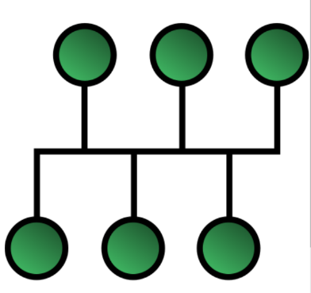**Draw a ring, bus, and star topology.**

**---**

**Challenge Questions:**

**Why might a supermarket chain use a WAN to connect all its stores?**

WANs are used to connect computers that are connected far apart from each other. As the stores are separated, they should a WAN to connect them.

**Explain the advantages of P2P networks regarding privacy when sharing files.**

In P2P networks, devices are connected directly without another computer in between and this makes sure that the files are only accessible by the sender and receiver. In a client-server style network, the shared files may be stored and accessed by the owners of the server.

**Most networks in use in schools and offices today are based on the star topology. Why do you think this topology is used?**

Page 201

**What is the most common authentication method in use?**

Passwords.

**What is access control?**

Controlling what each user can do with files; execute, write and/or read.

**What is social engineering?**

The act of convincing people to share private information like bank card details.

**Summarise the different types of cyberattacks.**

1. Phishing: Attempt to get sensitive, confidential information from a user.
2. Shoulder surfing: Where one tries to gain personal data by spying over the shoulders of the victim. For example, one may look over your shoulder while you are at an ATM to get your credit card details.
3. Technical weakness: Unpatched software without the latest security updates can be attacked. USB devices with malware can be a threat.

**Cyberattacks are increasing every year. Why do you think this is the case?**

Every year, more and more people gain access to the internet. This puts more users at risk of cyberattacks and this creates more chances for attackers to gain private information.

Most of the new internet users are usually from lower income countries where education is less developed. This puts them at an even greater risk as these users likely do not have the knowledge to spot attempts of cyberattacks on them.

Also, with computer education more widespread, more people decide to learn how to get into cyberattacking. Thus, cyberattacks are becoming more common.